US Cellular
Talend 8.0 – Applying the Patch

Document Information
This document provides the details with respect to applying upgrade version to studio and disabling the auto upgrade of version.
Document Edit History
Version | Date | Additions/Modifications | Prepared/Revised by
0.1 | 11/06/2025 | Draft | P.Sarath
0.2 | 11/06/2025 | Revised & Final | P.Sarath

Applying the Patch to Studio

- Open the Talend Studio and create a new connection. Click on the pencil icon and add the details for creating the connection.

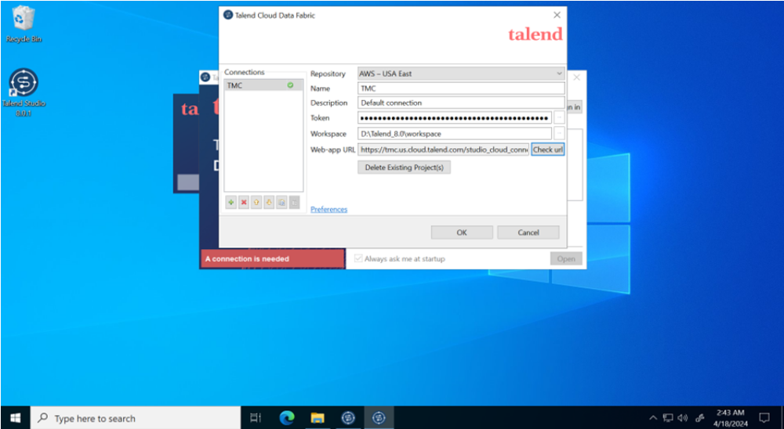

- Once the connection is created, test the connection by clicking on “Check URL” button.

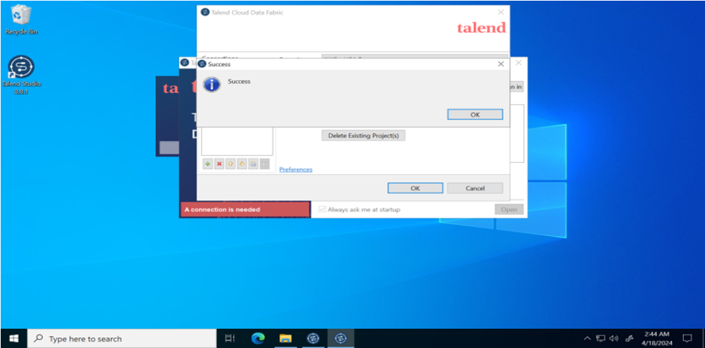

- Click on Preference-> Update settings

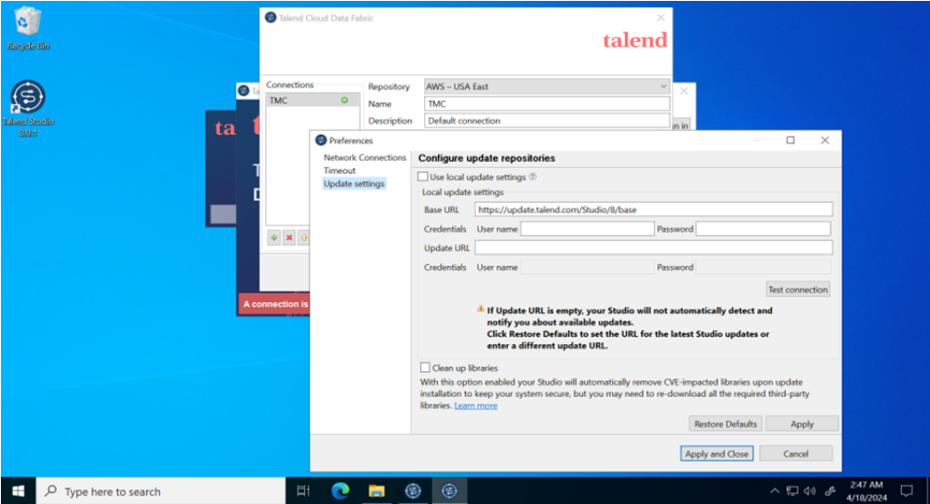

- In the Update URL field, enter the URL of the repository for Talend Studio feature updates. Specify which monthly patch you wish to apply to all Studio instances. The format is as follows: https://update.talend.com/Studio/8/updates/R20YY-MM/. You will replace the YY and MM with the year and month of the required patch level, respectively.
Below the update URL is : https://update.talend.com/Studio/8/updates/R2024-02/

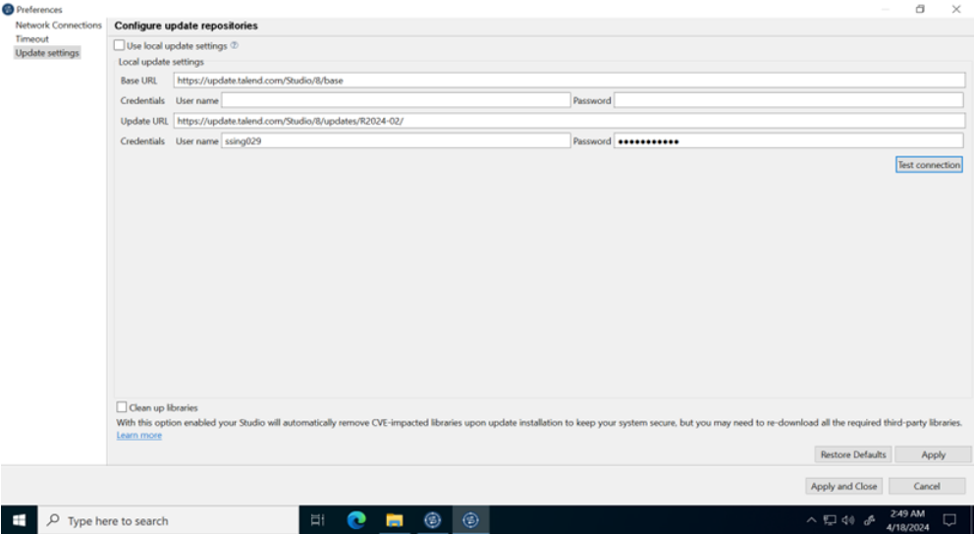

- Enter the credentials .i.e username and password and click on “Test Connection” button.

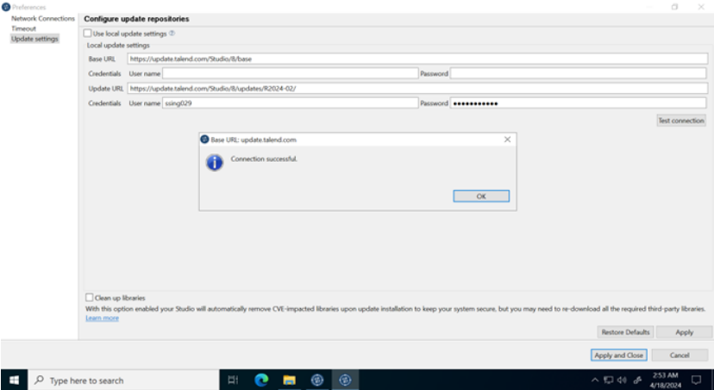

- Click on “Apply and Close” button.

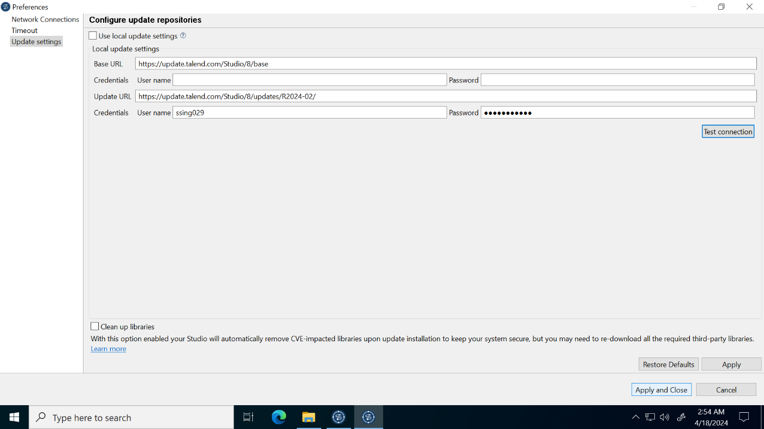

- Click on “Open” button.

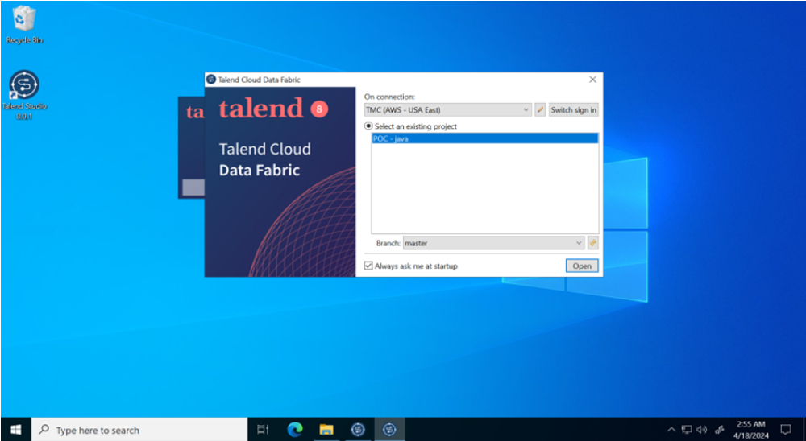

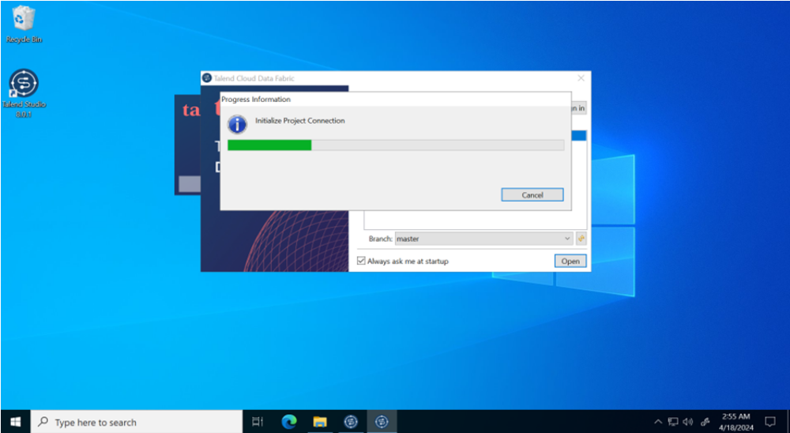

- Click on “Next” button.

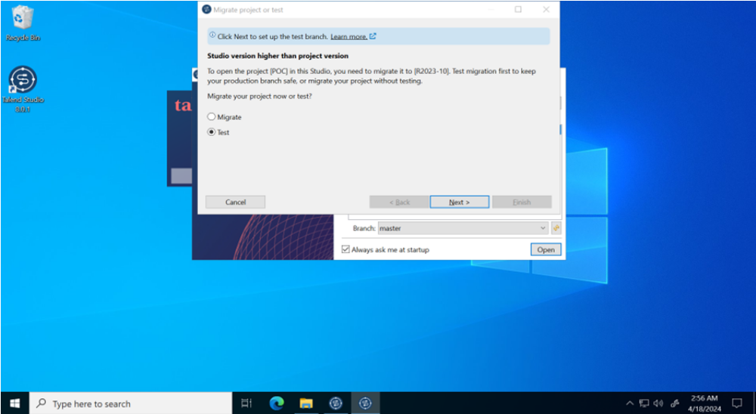

- Once the application is open , click on the notification of available updates on bottom right.

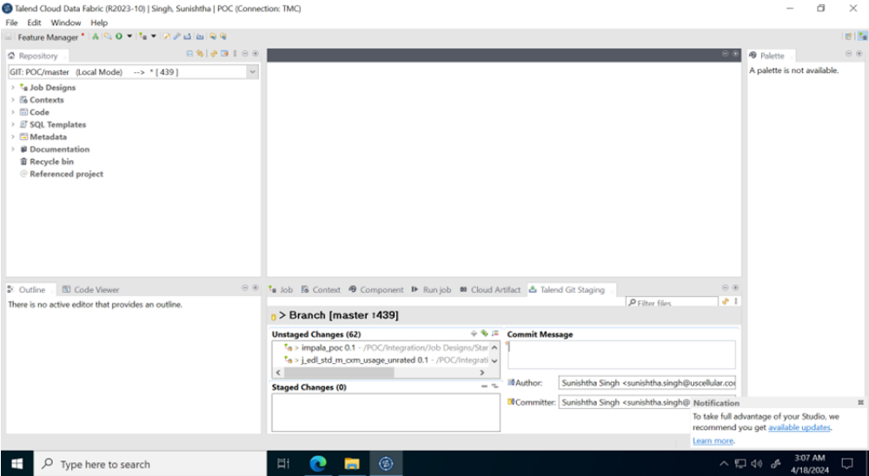

- Verify the patch which is going to be applied and click on “Yes,Update” button.

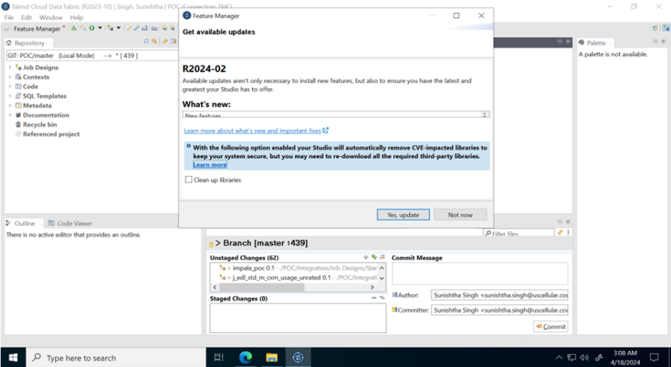

- Click on “Restart Now” button.

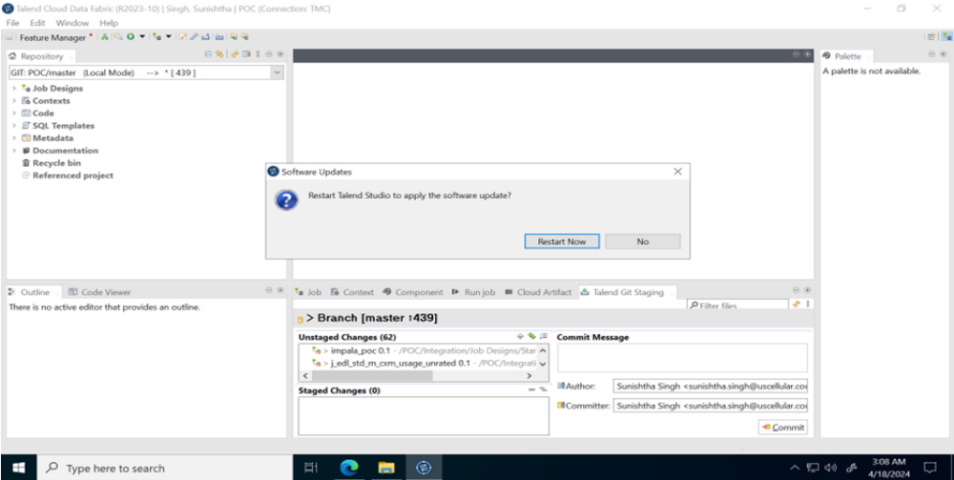

- Once the Studio is restarted, click on “Next” button.

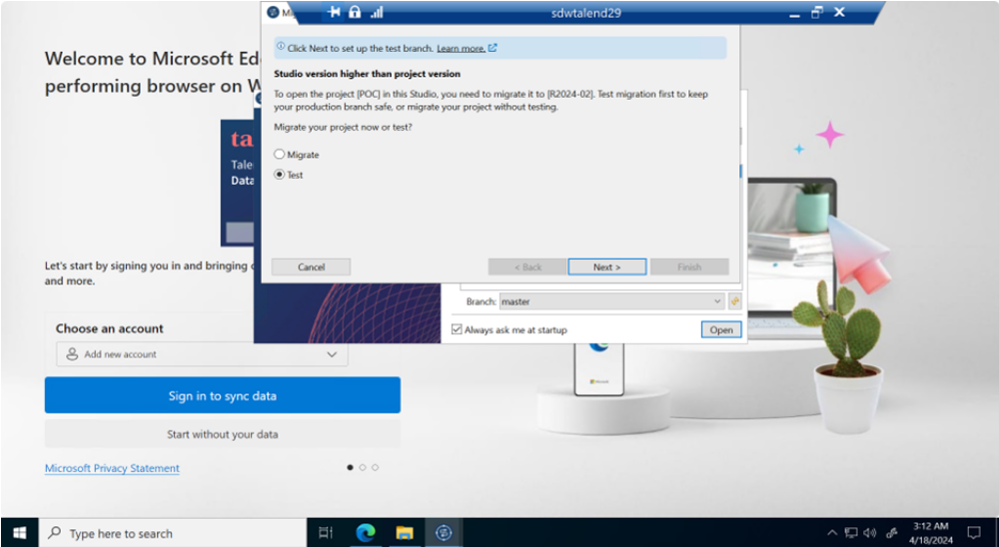

- Click on “Finish” button.

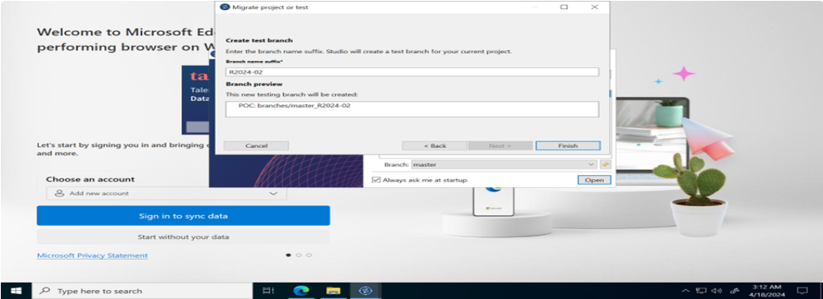

- Click on Windows->Preferences

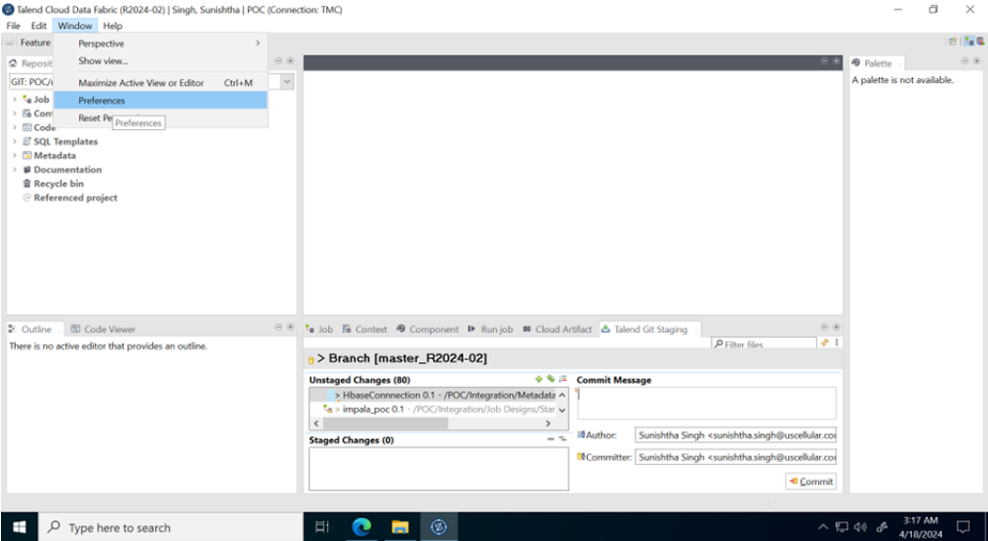

- Click on Talend->Update Settings

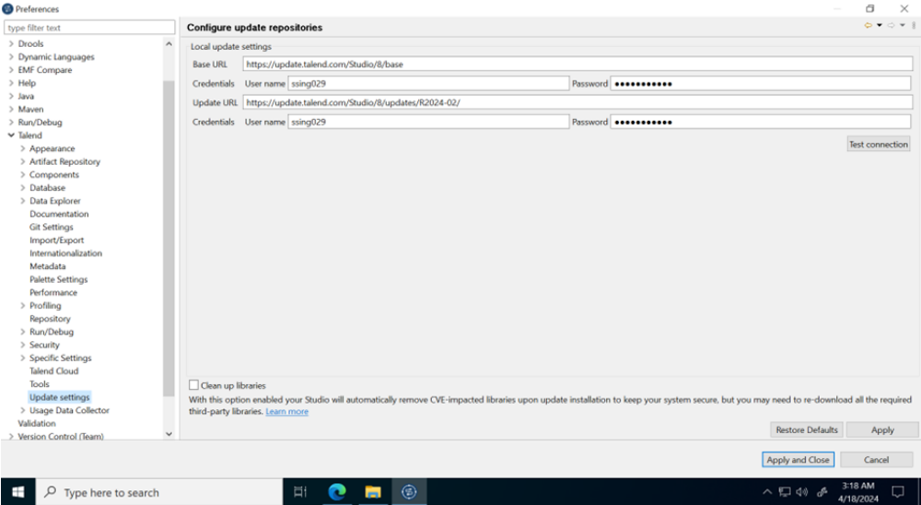

- Click on “Restore Defaults” button and remove the Update URL.

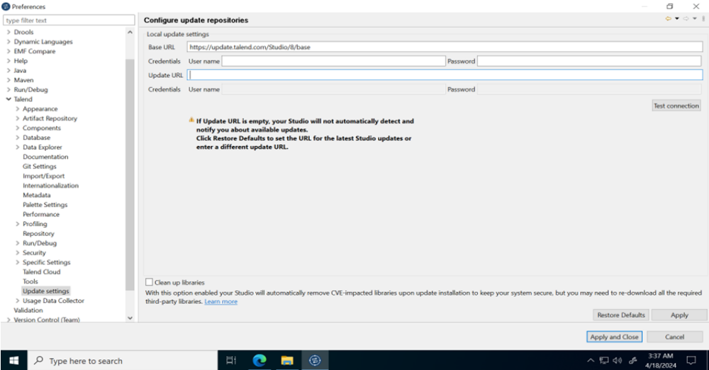

- Click on “Apply and close button”

